Department of Computer Engineering
Faculty of Engineering
Khon Kaen University

Experiment DSP-04: Simple Audio Signal Synthesis and Effects

Objectives:
- To introduce how to digitally synthesize simple signals
- To introduce some effects and learn how to implement

Introduction:

A. Dual Tone Multi-Frequency (DTMF)
Dual Tone Multi-Frequency is a format for transmitting data by telephone and radio. The tones you hear when you press the keys on your phone are the DTMF tones. It was first designed by engineers at Bell Labs for sending data across long distances over a variety of systems.
DTMF signal is one that consists of only the sum of two pure sinusoids at valid frequencies. The table 1 below shows the format of DTMF. Each digit is represented by two tones, determined by the intersection of the row and column where the digit sits. Two tones are used as opposed to one to provide protection against false digits appearing during transmission due to noise.

Table 1 Key positions and corresponding DTMF tones
1 | 2 | 3 | A | 697Hz
4 | 5 | 6 | B | 770Hz
7 | 8 | 9 | C | 852Hz
* | 0 | # | D | 941Hz
1209Hz | 1336Hz | 1477Hz | 1633Hz

An example of DTMF tones in use would be, when your call is answered by a recorded message which instructs you to "press a key" to be transferred to a particular department or extension. It is also used to allow users to enter, for example, their credit card number to obtain a balance, when calling your credit card company.

B. Musical Notes
Musical notes are arranged in groups of twelve, called octaves. The notes that we’ll be using are in the octve containing frequencies ranging from 440 Hz to 880 Hz. The twelve notes in each octave are logarithmically spaced in frequency, with each note frequency being times the frequency of the next lowest note. Thus, a 1-octave pitch shift upwards corresponds to a doubling of the frequencies of the notes in the original octave. The table 2 shows the ordering of notes in the octave to be used to synthesize the music for the experiment as well as the fundamental frequencies for those notes.
Table 2 Notes in the 440-880 Hz octave
Note | Frequency (Hz)

C. Sound Effects

C.1 Echo
The echo is one of the simplest effects used in musical signal processing. The echo filter adds the current input to a delayed input with a gain that is less than 1 in order to produce the output. This is accomplished by using the delay routine shown below in figure 1
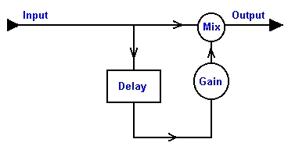Figure 1 Illustration of an echo system

C.2 Reverb
By putting a few echo filters in series, the user can create a reverberating filter, which causes the output to sound like a person yelling into the mountains. These filters are also known as comb filters. This is one of the main effects that are used on electric guitars to make notes last a lot longer and fade out. Below is the schematic for a basic reverb filter.
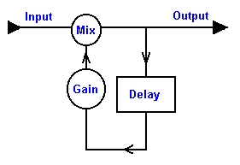Figure 2 Illustration of reverb system
Experiment:
1) Musical notes
  - Enter the following code to an M-file named whatever you want to.

% Beginning of the m-file
Fs = 8000; % sampling rate
t = 0.5; % duration
n = 0:t*Fs-1; % calculate the number of samples
nTs = n/Fs;
pit = 2*pi*nTs; % calculate the pitch

f = [523.35, 587.33, 659.26, 698.46,…
783.99, 880.1, 987.77, 1046.50];

tone = [];
for i = 1:length(f);
tone = [tone sin(f(i)*pit)];
end
sound([tone fliplr(tone)], Fs);
% End.

1.2 Run the M-file and report what you get.
1.3 Referred to the score in the appendix, write a program that creates the signal representing those notes of the song.
1.4 Play back the created signal. What is the name of the song?
1.4 Using the built-in function ‘wavwrite’, write the song as a wav file, named whatever you want to.

2) Sound effects
2.1 Using the built-in function ‘wavread’, load sampled data and sampling rate from wav file named ‘good.wav’.
2.2 Determine recording time of the signal in 2.1
2.3 Determine the number of samples needed for the 500-ms time delay.
2.4 Write a program that can perform the echo system, shown in Figure 1, for the signal in 2.1 with
Gain = 0.5 and delay = 500 ms.
2.5 Report what happens when playing back the processed signal with twice as high as the sampling frequency.
2.6 Report what happens when playing back the processed signal with twice as low as the sampling frequency.
2.7 Write a program that can perform the reverb system, shown in Figure 2, on the signal in 2.1with Gain = 0.5 and delay = 500 ms.
2.8 As the delay is fixed at 500 ms, try the program in 2.7 with different gains such as 0.3, 0.8 and 1.0 etc. and report the effect of the changes you can notice.
2.9 As the delay is fixed at 500 ms, try the program in 2.7 with a sinusoidal gain, . Determine the value of that makes an interesting effect to you.
2.10 As the gain is fixed at 0.5, try the program in 2.7 with different delays such as 100 ms, 800 ms
and 2000 ms etc. and report the effect of the changes you can notice.

Questions:
1. Assuming Fs = 8000 Hz, write a program that generates and plots all of DTMF tones having 1 second long each.

Nawapak Eua-anant and Rujchai Ung-arunyawee
13 December 2548
Appendix
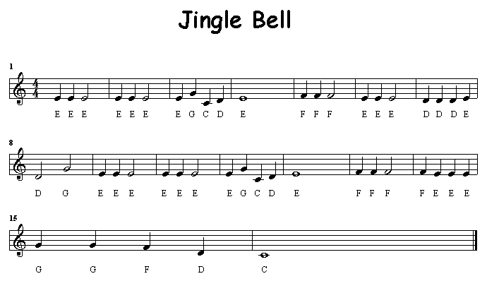

เพลงนี้ ใน 1 ห้องมี 4 จังหวะ

โน้ตตัวดำ แทน 1 จังหวะ โน้ตตัวขาว แทน 2 จังหวะ โน้ตตัวกลม แทน 4 จังหวะ
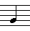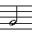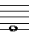
เอกสารส่วนนี้จัดทำโดย
นายศฤงคาร เหลืองทองคำ 401991-6
นศ. ภาควิชาวิศวกรรมคอมพิวเตอร์
Name:______________________________________________________________ID:________________

In class assignment DSP04
1. Draw block diagram and equation of an echo system that produces 2 echo sounds at the same time (delayed by 100 ms and 200 ms respectively) while the sampling rate is 10000 samples/sec.

2. What knowledge do you get from this lab?

