Deploying Web Services Using Web Service Deployment Descriptors (WSDD)

WSDD files are written by using XML and allow you to have maximum configuration regarding your web service and enables you to have custom type mappings, control different providers for your web service and also let you have handlers.

More about WSDD
Using Web service deployment descriptors enables you to have flexibility and allows you to use all the (really cool!) advanced features provided by Axis 1.0. You can control which provider handlers are used to expose components as Web services. The three major providers are listed below:
• Java-RPC Provider: This provider is used to expose any Java class as a RPC-based Web service.
• Java-MsgProvider: This provider is used to expose any Java class as a message-based Web service.
• EJBProvider: This provider is used to expose any Enterprise JavaBean as a Web service. Currently, Axis 1.0 only supports state-less EJB’s to be exposed as RPC-based Web services. In the future, it will include support for stateful and message-based message-driven beans.

Setup
We will be using the same TaxService class we used in the previous part of the tutorial. The first thing you should do is make a copy of the TaxService.jws file in a folder which you use to store your Java files (such as C:\axis-1_1\samples\taxservice) and rename it to TaxService.java. Then open up the TaxService.java file in your IDE/editor. In order to deploy your web service, you must first compile it. After making sure that you have the required JARs in your classpath, compile it. If successful, you will end up with a TaxService.class file in your folder. Make a copy of this class file and paste it into the c:\jakarta-tomcat-5.0.16\webapps\axis\WEB-INF\classes folder of your Axis installation directory of your J2EE server. I know that you are doing a lot of copying and pasting, but this is only because I am instructing without an IDE in mind. More than likely, if you have an IDE, you won't have to do so much file manipulation. For example, most IDE's have a feature where you can set the class output directory to the c:\jakarta-tomcat-5.0.16\webapps\axis\WEB-INF\classes folder.

Writing the deployment descriptor
Now you are ready to write a deployment descriptor to deploy your service. Create a file called deploy.wsdd in the same directory as your TaxService.java file and type the following information.

<deployment xmlns="http://xml.apache.org/axis/wsdd/"
xmlns:java="http://xml.apache.org/axis/wsdd/providers/java">
<service name="TaxService" provider="java:RPC">
<parameter name="className" value="TaxService"/>
<parameter name="allowedMethods" value="*"/>
</service>
</deployment>
As you can see, this is an XML document with elements specific to Axis. The element named service has an attribute called name. This attribute contains the name of your web service. The provider attribute states that this web service is a Java-RPC (remote procedure call) type web service. Next you have two parameters. The first parameter, called className states the name of your web service class file, which is TaxService. The second parameter, allowedMethods, contains the methods you want to expose to the web service. An asterisk (*) indicates that all public methods will be exposed.

Ready for Deployment
Now you’re ready to deploy your Web service. We will be using a client of a web service called AdminClient, which is provided in Axis 1.0, to deploy our own service. In order to use AdminClient you must make sure that you have all the Axis JARs in your classpath as well as servlet.jar, which is provided with your J2EE server. If you are using Tomcat, it can be found in C:\jakarta-tomcat-5.0.16\common\lib. Now, launch a command prompt, switch to the C:\axis-1_1\samples\taxservice directory and type in the following:

> java org.apache.axis.client.AdminClient deploy.wsdd

If successful, it will output this information.
Processing file deploy.wsdd
<Admin>Done processing</Admin>
If you see the above output, then congratulations! You have just deployed your first web service using deployment descriptors.
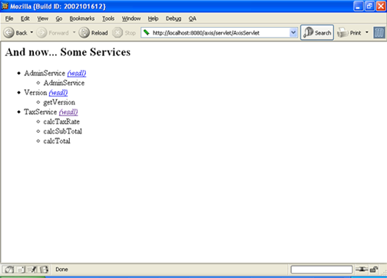
To test your deployment, you can launch your web browser and type in the following URL: http://localhost:8080/axis. Then click on ‘View the list of deployed Web services’ and you will see a list of Web services along with their public methods, including TaxService! (Note: With JWS deployment, you will not see your web service listed, it will only be listed with standard deployment.)

Undeployment
Now that you have seen how to deploy a web service, you will see how to undeploy it. Undeploying is done similar to deploying except this time, we have to create an undeployment descriptor. The first thing you should do is create a file named undeploy.wsdd in the C:\axis-1_1\samples\taxservice directory, and type the following:

<undeployment xmlns="http://xml.apache.org/axis/wsdd/">
<service name="TaxService"/>
</undeployment>
After saving this file, open up a command prompt, switch to the C:\javastuff directory and use the AdminClient to undeploy it as follows:

> java org.apache.axis.client.AdminClient undeploy.wsdd
If successfully, it will output some information:
Processing file undeploy.wsdd
<Admin>Done processing</Admin>
There, now you have successfully undeployed your web service. You will see TaxService is gone from the list of web services if you go to your Axis servlet at http://localhost:8080/axis/servlet/AxisServlet.

Conclusion
In this document, we examined what Web service deployment descriptors are and how to use them. As you can see, WSDD files enables one to use the full flexibility and power of Axis with minimal effort. When your Web services become complex, you can see the power of WSDD files and how easily they enable you to use the advanced features of Axis

